Digital procedure to correct perspective for timelapse camera
Loïc Van Audenhaege¹, Daniel O. B. Jones¹
¹National Oceanography Centre, Southampton, UK
Emails: loicva@noc.ac.uk/loic.vanaudenhaege@gmail.com
Please cite as Van Audenhaege et al. (submitted)
This document outlines the mathematical demonstration used to correct time-lapse images and annotations for perspective, complementing a coded procedure available on GitHub - LoicVA/Perspective-transformation-for-timelapse-imagery
Note that this script relies on a few assumptions:
- The seabed is flat (slope = 0°).
- The camera pan is null.
- The principal point is in the centre of the image.
- The angle of vertical acceptance remains below the horizontal line (see Figure 1) to avoid an infinite propagation in the water column which cannot be resolved.
(1) Correction of angles of acceptance for water refraction
If necessary, angles of acceptance can be corrected for water refraction using the Snell’s law, especially when the camera is enclosed in an air dome.
(1)
$$n_{1}×sin\left(α_{air}\right)=n_{2}×\sin\left(α_{water}\right)$$
which becomes after readjustment,
(2)
$$α_{water}=\sin^{-1}\left(\frac{n_{1}}{n_{2}}×\sin\left(α_{air}\right)\right)$$
Given typical refractive indices – n₁ (air) = 1.00 and n₂ (seawater) = 1.33-1.34 – vertical and horizontal angles of acceptance can be adjusted using α_{air} provided by the manufacturer.
(2) Real-world correspondence of corner coordinates
Consider a camera mounted at height ON above a flat seafloor, tilted at a known angle θ. The vertical (α) and horizontal (β) acceptance angles are given. Point P represents the principal point, where the optical axis intersects the image plane¹ (Figure 1). This camera produces an image with a fixed pixel width (w) and pixel height (h).

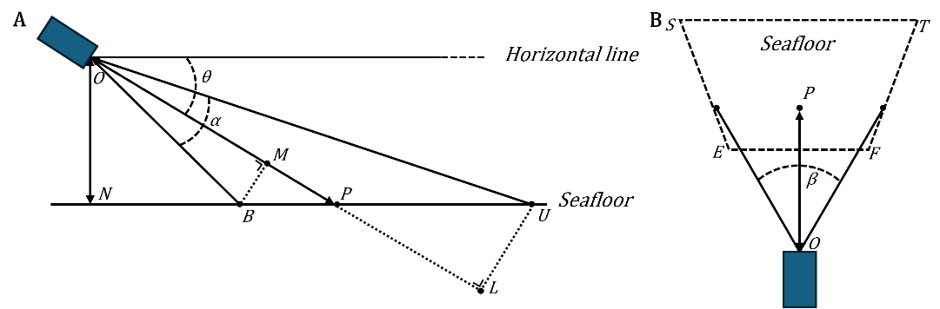
Figure 1. Diagram illustrating the parameters used for the mathematical demonstration: (A) lateral view and (B) top-down view showing the imprint of the image over a flat seafloor. All abbreviations correspond to Wakefield and Genin¹, except for abbreviations ‘M’ and ‘L’, added to correspond to Durden et al.².
The goal of this mathematical demonstration will be to isolate an expression allowing to convert image dimensions from pixel to real-world coordinates, including the width at the lower and upper base of the image along with the height of the image. It will enable to compute the area of the imprint.
Vertical projection of the image
Let assume A, a point positioned between B and U (Figure 1A; see also Figure 1A in Wakefield and Genin¹). To calculate the horizontal scale of the real-world coordinates, we isolate BA from formula (4) in Wakefield and Genin¹ (see full development in section 5).
$$BA=\left(ON×\frac{\left(1+X×\tan\left(θ\right)\right)}{\left(\tan\left(θ\right)-X\right)}-ON×\left(\frac{1}{\tan\left(θ+\frac{α}{2}\right)}\right)\right)$$
where
$$X= \tan\left(\frac{α}{2}\right)×\left(\frac{ba}{bp}-1\right)$$
Regardless of the horizontal scale, BU, the vertical extent of the image, can be calculated by replacing ba by h considering ba = bu, and bp by h/2; h being the height in pixel of the image.
Horizontal projection of the image
(1) Lower base of the image
Using formula (5) in Wakefield and Genin¹, OB can be isolated as follows:
$$OB= \frac{ON}{\sin\left(θ+\frac{α}{2}\right)}$$
Including corrections from Durden et al.², OB must be converted to OM (Figure 1A). This correction is necessary as Wakefield and Genin¹ does not preserve a trapezoidal image imprint (see in Figure 6B in Durden et al.²).
$$OM=\cos\left(\frac{α}{2}\right)×OB$$
Considering that ef = w, w being the width in pixel of the image, the horizontal scale at the baseline (S_{hb} = ef/EF) can be calculated using formula (7) of Wakefield and Genin¹.
$$S_{hb}=\frac{w}{\left(2×OM×\tan\left(\frac{β}{2}\right)\right)}$$
The real-world reprojection of the image lower base becomes (Figure 1B):
$$EF=\frac{w}{S_{hb}}$$
(2) Upper base of the image
Using formula (5) in Wakefield and Genin¹, OU can be isolated as follows:
$$OU=\frac{ON}{\sin\left(θ-\frac{α}{2}\right)}$$
Note that α/2 becomes negative since U is located above the principal point.
Including corrections from Durden et al.², OU must be converted to OL (Figure 1A). This correction is necessary as Wakefield and Genin¹ does not preserve a trapezoidal image imprint (see in Figure 6B in Durden et al.²).
$$OL=\cos\left(\frac{α}{2}\right)×OU$$
Considering that ef = w, w being the width in pixel of the image, the horizontal scale at the baseline (S_{hu} = ef/EF) can be calculated using formula (7) of Wakefield and Genin¹.
$$S_{hu}= \frac{w}{\left(2×\left(OL\right)×\tan\left(\frac{β}{2}\right)\right)}$$
The real-world reprojection of the image upper base becomes (Figure 1B):
$$ST=\frac{w}{S_{hu}}$$
Image areal imprint
The real-world imprint of the image can be derived from the formula calculating the area of an isosceles trapezoid.
$$Image areal imprint=\frac{\left(EF+ST\right)}{2}×\left(BU\right)$$

(3) Computation of the homography matrix
Given the image’s pixel width (w) and height (l), the coordinates of the corners in the original image are:
$$\left(\begin{matrix}\begin{matrix}a \\ b\end{matrix} \\ c \\ d\end{matrix}\right)=\left(\begin{matrix}\begin{matrix}0, 0 \\ w, 0\end{matrix} \\ 0,h \\ w,h\end{matrix}\right)$$
a being the upper left corner, b being the upper right corner, c being the lower left corner, a being the lower right corner.
Using these distances, we can make a correspondence with the real-world coordinates of points a, b, c, and d, by estimating their new position after transformation.
$$\left(\begin{matrix}\begin{matrix}a_{t} \\ b_{t}\end{matrix} \\ c_{t} \\ d_{t}\end{matrix}\right)=\left(\begin{matrix}\begin{matrix}0, 0 \\ ST, 0\end{matrix} \\ \frac{ST}{2}-\frac{EF}{2},BU \\ \frac{ST}{2}+\frac{EF}{2},BU\end{matrix}\right)$$
With the set of corresponding points, a transformation matrix H can be computed using OpenCV getPerspectiveTransform() function (v4.9.0.80, Python 3.7). This function yields a 3×3 homography matrix with 8 degrees of freedom. The unit of this transformation is inherited from the camera height above the seafloor.
The dimensions of the transformed image will be used to plot the transformed image using the OpenCV warpPerspective() function. Each pixel of the perspective transformed image will then correspond to one metric unit.
$$\left(w_{t},{ l}_{t}\right)=\left(\left(ST\right), \left(BU\right)\right)$$
(4) Applications
Table 1. Parameters used in the Python script, as an example. Angles of acceptance were already corrected for water refraction.
ON | 1450 mm
θ | 45°
α | 57°
β | 40°
w | 6000 px
h | 4000 px

Encoding study-specific parameters (Table 1) in the Python routine allows to compute a homography matrix H.
$$H=\left(\begin{matrix}0.583510539 & 0.500873911 & 0.000 \\ 0.000 & 1.304604944 & 0.000 \\ 0.000 & 0.000286127 & 1.000\end{matrix}\right)$$
The transformed image can then be generated using OpenCV warpPerspective() function, after calculating the new image dimensions.
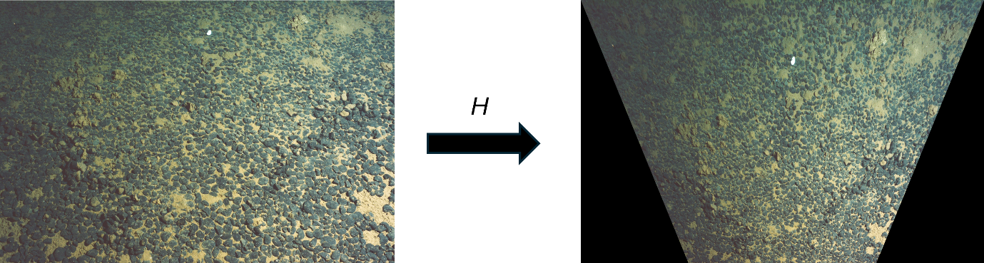
Figure 2. The perspective transformation applied to the original image, based on real-world and pixel coordinates used to compute the homography matrix H. The corrected image uses a real-world scale, with each pixel representing 1 mm.
This transformation can also be applied to any annotations made on the original image, enabling standardized computation of ecological metrics. Orientation of the axes are positive downward for X and to the right for Y, with the origin being the upper-left corner of the image.
Additionally, a regular grid (e.g., 100 mm spacing) can be overlaid on the transformed image (Figure 3). Using the inverse of the homography matrix, the metric grid can be projected over the original pixel coordinate system.
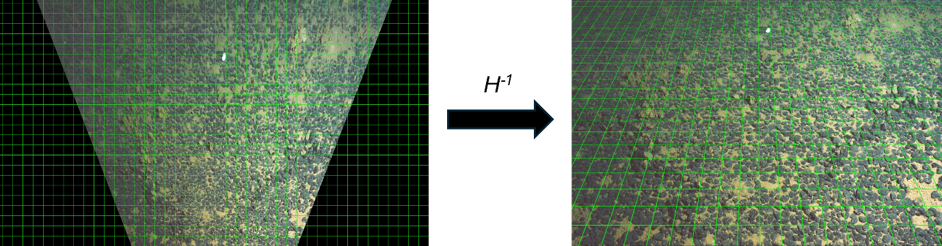
Figure 3. Reversing the transformation using the inverse homography matrix H, enabling overlay of a perspective grid onto the original image.
Image resolution, expressed in mm per pixel, can be mapped over the original image. This can be carried out by applying iteratively the homography matrix to the four corner coordinates of each pixel. The application of the Shoelace formula on the transformed coordinates derives the area covered by that pixel after perspective transformation, in real-world units (mm² per pixel²). A row-wise average of these values will allow mapping the resolution across the image to visualise the non-linear increase of the resolution ratio as the length of the line-of-sight increases (i.e., the distance from the camera to the point captured by the pixel).
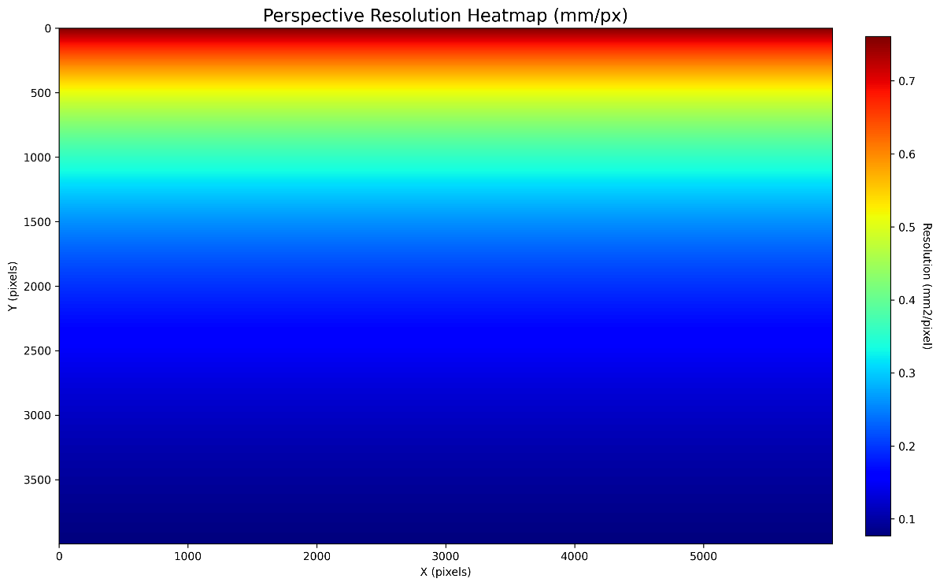
Figure 4. Heatmap of the image resolution, expressed in mm per pixel, allowing to visualise the non-linear change in image resolution due to perspective, from 0.08 to 0.76 mm² per pixel. The top edge of the image represents pixel located further away from the camera.
This procedure also enables to convert annotation coordinates to real-world coordinates, ensuring annotations and derivatives (e.g., rates of activity) are standardised and interpretable across the whole image (Figure 5).
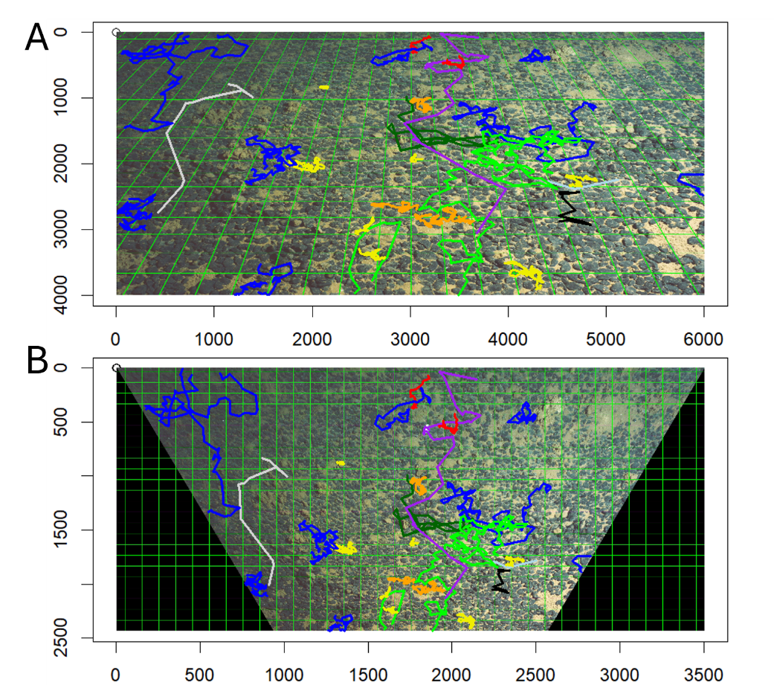
Figure 5. Examples of annotations that were converted from (A) the pixel coordinate system of the image to (B) a metric coordinate system.
(5) Isolation of BA from formula (4) in Wakefield and Genin¹
(1) Start from the original equation:
$$ba=bp×\left(1+\frac{tan\left(θ-\arctan\left({ON}/{\left(BA+ON×\cot\left(θ+α/2\right)\right)}\right)\right)}{\tan\left(\frac{α}{2}\right)}\right)$$
(2) Divide both sides by bp and subtract 1:
$$\frac{ba}{bp}-1=\frac{tan\left(θ-\arctan\left({ON}/{\left(BA+ON×\cot\left(θ+α/2\right)\right)}\right)\right)}{\tan\left(\frac{α}{2}\right)}$$
(3) Define substitution:
$$X=\tan\left(\frac{α}{2}\right)×\left(\frac{ba}{bp}-1\right)$$
(4) Then:
$$X=\tan\left(\frac{α}{2}\right)×\left(\frac{tan\left(θ-\arctan\left({ON}/{\left(BA+ON×\cot\left(θ+α/2\right)\right)}\right)\right)}{\tan\left(\frac{α}{2}\right)}\right)$$
$$X=tan\left(θ-\arctan\left(\frac{ON}{\left(BA+ON×\cot\left(θ+α/2\right)\right)}\right)\right)$$
(5) Use identity $\tan\left(A-B\right)=\left(\frac{\tan\left(A\right)-\tan\left(B\right)}{\left(1+\tan\left(A\right)×\tan\left(B\right)\right)}\right)$:
$$X=\frac{\left(\tan\left(θ\right)-{ON}/{\left(BA+ON×\cot\left(θ+α/2\right)\right)}\right)}{\left(1+\tan\left(θ\right)×{ON}/{\left(BA+ON×\cot\left(θ+α/2\right)\right)}\right)}$$
(6) Let $Y=BA+ON×\cot\left(θ+α/2\right)$:
$$X=\frac{\left(Y×\tan\left(θ\right)-ON\right)}{\left(Y+ON×\tan\left(θ\right)\right)}$$
(7) Solve for Y:
$$X×\left(Y+ON×\tan\left(θ\right)\right)=Y×\tan\left(θ\right)-ON$$
$$X×Y+X×ON×\tan\left(θ\right)=Y×\tan\left(θ\right)-ON$$
$$Y×\left(X-\tan\left(θ\right)\right)=-ON×\left(1+X×tan\left(θ\right)\right)$$
$$Y= \frac{ON×\left(1+X×tan\left(θ\right)\right)}{\left(\tan\left(θ\right)-X\right)}$$
(8) Substitute back:
$$BA=Y-ON×\cot\left(θ+\frac{α}{2}\right)$$
(9) Final result:
$$BA=ON×\left(\frac{\left(1+X×\tan\left(θ\right)\right)}{\left(\tan\left(θ\right)-X\right)}-\frac{1}{\tan\left(θ+\frac{α}{2}\right)}\right)$$

References
1. Wakefield, W.W., and Genin, A. (1987). The use of a Canadian (perspective) grid in deep-sea photography. Deep Sea Research Part A. Oceanographic Research Papers 34, 469-478. 10.1016/0198-0149(87)90148-8.
2. Durden, J.M., Schoening, T., Althaus, F., Friedman, A., Garcia, R., Glover, A.G., Greinert, J., Jacobsen Stout, N., Jones, D.O.B., Jordt, A., et al. (2016). Perspectives in visual imaging for marine biology and ecology: from acquisition to understanding. In Oceanography and Marine Biology: An Annual Review, R.N. Hughes, D.J. Hughes, I.P. Smith, and A.C. Dale, eds. (CRC Press), pp. 1-72. 10.1201/9781315368597.

